Infrastructure as Code (IaC)
Infrastructure as Code (IaC) is a modern DevOps practice where servers, networks, and cloud resources are automatically provisioned and managed using code instead of manual configuration. It helps maintain consistency, speed, and reliability across deployments.
- Automates infrastructure setup using scripts or configuration files.
- Ensures consistent environments across development, testing, and production.
- Enables faster and repeatable deployments.
- Reduces human errors caused by manual configuration.
- Improves scalability and disaster recovery.
- Supports version control for infrastructure changes (like Git).
It treats infrastructure components like software, allowing you to use development practices like version control, testing, and CI/CD pipelines.
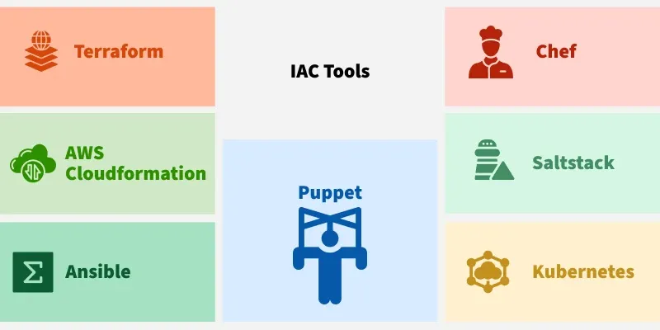
Core Concepts of IaC
1. Idempotency
This is a critical concept in IaC. An idempotent operation is one that can be applied multiple times without changing the result beyond the initial application. In IaC terms, this means that running your IaC script over and over will always result in the same defined state. If the infrastructure already matches the desired state, the tool will simply do nothing. This makes applying updates safe and predictable.
2. Immutable Vs Mutable Infrastructure
- Mutable Infrastructure: This is the traditional "pet" model. Servers are provisioned and then updated, patched, and modified in place over their lifetime. This process can lead to configuration drift and makes servers fragile and unique.
- Immutable Infrastructure: This is the modern "cattle" model favored by IaC. When a change is needed, the existing server is not modified. Instead, a new server is provisioned from a fresh image with the desired changes, and the old one is terminated. This ensures a clean, predictable, and fully reproducible state.
Declarative Vs Imperative Approaches
IaC tools follow one of two main approaches to defining infrastructure:
Feature | Declarative Approach | Imperative Approach
Philosophy | Specifies the desired state (the "what") of the infrastructure. | Details the exact steps or commands (the "how") to achieve the desired state.
Execution | The IaC tool determines and performs the actions needed to reach the desired state. | Requires the user to execute commands in the correct sequence.
State Management | The tool tracks the current state of the infrastructure, simplifying updates and teardown. | Does not inherently track state; the user is responsible for managing changes.
User Focus | Simplifies the process; users define what they want. | Demands detailed instructions; the user defines how to achieve the result.
Handling Changes | Automatically calculates and applies the necessary changes to match the new desired state. | The user must write a new script to figure out and apply the changes manually.
Example | Defining a resource in a Terraform file: resource "aws_instance" "web" { ami = "ami-123" instance_type = "t2.micro"} | Writing a shell script: #!/bin/bashaws ec2 run-instances \ --image-id ami-123 \ --instance-type t2.micro
IaC in the DevOps Lifecycle
IaC is a fundamental enabler of DevOps practices by bridging the gap between development and operations:
- Enabling CI/CD: IaC integrates seamlessly into Continuous Integration/Continuous Delivery (CI/CD) pipelines. A code change can trigger a pipeline that not only tests the application but also provisions or updates the necessary infrastructure to run it.
- Creating Ephemeral Environments: Teams can instantly spin up new, production-like environments for development, testing, or user acceptance testing (UAT). This allows developers to test their code in a realistic setting before merging, catching bugs earlier.
- Breaking Down Silos: When infrastructure is code, it lives in the same VCS as the application code. Developers and operations engineers can collaborate on the same files, review changes through pull requests, and gain a shared understanding of the entire system.
Popular IaC Tools
Different IaC tools are optimized for different tasks. They generally fall into three categories:
1. Infrastructure Provisioning Tools
These tools are primarily used to create, modify, and destroy the foundational infrastructure components like virtual machines, networks, and databases. They are almost always declarative.
- Terraform: A widely-used, open-source tool by HashiCorp. Its key feature is being cloud-agnostic, supporting AWS, Azure, GCP, and many other providers. It uses a declarative language (HCL) and excels at managing complex, multi-cloud infrastructure.
- AWS Cloud Formation: The native IaC tool for AWS. It allows you to define AWS resources in JSON or YAML templates. Its main strength is its deep integration with all AWS services.
2. Configuration Management Tools
These tools specialize in configuring the software on existing servers. They install packages, manage configuration files, and ensure services are running.
- Ansible: A very popular open-source tool known for its simplicity and agentless architecture. It uses YAML "playbooks" that are easy to read and operates over SSH. It can be used for both imperative (tasks) and declarative (state) management.
- Puppet: A mature, agent-based tool that uses a declarative, model-driven approach. A central "Puppet Master" server manages the "Puppet Agents" on each machine, enforcing the desired state.
- Chef: A powerful and flexible agent-based tool that uses a Ruby-based DSL (Domain-Specific Language). It's often described as more imperative, giving developers fine-grained control over configuration steps using "recipes" and "cookbooks."
- Salt Stack (Salt): A high-speed, event-driven automation tool. It can operate in either an agent-based model or an agentless model over SSH and is known for its performance and scalability.
3. Container Orchestration Tools
While not strictly traditional IaC, these tools manage the infrastructure and lifecycle of containerized applications in a declarative way.
- Kubernetes (K8s): The de-facto standard for container orchestration. Kubernetes automates the deployment, scaling, and management of containerized applications. Users define the desired state of the application (e.g., "run 3 replicas of this container and expose it on port 80") using YAML manifests.
Note on Convergence: The lines between these categories are blurring. For example, Terraform can use "provisioners" to run configuration scripts, and Ansible has modules to provision cloud infrastructure.
Common Use Cases for IaC
Infrastructure as Code has a wide range of applications across different domains:
- Cloud Computing: Provisioning and managing all cloud resources, such as virtual machines, storage, databases, and VPCs.
- DevOps & CI/CD: Automating the creation of development, staging, and production environments as part of a CI/CD pipeline.
- Web Application Deployment: Defining and deploying an entire application stack, including web servers, application servers, load balancers, and databases.
- Networking: Automating the deployment and management of networks, including creating and managing subnets, security groups, and firewalls.
- Big Data: Automating the deployment and management of big data infrastructure, such as setting up clusters for Apache Hadoop or Apache Spark.
- Disaster Recovery: Quickly and reliably recreating an entire production infrastructure in a different region in the event of a failure.
Common Challenges and Pitfalls
While powerful, IaC is not without its challenges:
- Learning Curve: IaC tools and concepts can be complex. Teams need to invest time in learning the specific tool (e.g., Terraform, Ansible) and the declarative/immutable paradigms.
- State Management: The state file can become a bottleneck. If it gets corrupted, lost, or locked, it can be difficult to manage your infrastructure.
- Configuration Drift: This occurs when manual changes are made to the infrastructure, causing it to "drift" from the state defined in the code. This breaks the "single source of truth" and can cause future IaC runs to fail or have unintended consequences.
- Tooling Complexity: Choosing the right tool (or combination of tools) can be difficult. A common stack is using Terraform for provisioning and Ansible for configuration, but this adds to the complexity.
The Future of IaC: GitOps and AIOps
- GitOps: This is the evolution of IaC. In a GitOps model, the Git repository is the single source of truth. An automated agent (like Argo CD or Flux) continuously monitors the repository and the live infrastructure, automatically applying any changes from Git to the cluster. This makes the CI/CD process even more automated and auditable.
- AIOps: The integration of AI and machine learning with IaC promises self-healing infrastructure. AI models could detect anomalies (e.g., a server crashing), identify the root cause, and automatically trigger an IaC-defined remediation (e.g., provisioning a new server) without human intervention.
difference between ansible and lac
The main difference is that IaC (Infrastructure as Code) is a concept, while Ansible is a tool that can implement that concept.
IaC (Infrastructure as Code) | Ansible
A methodology or practice | An automation/configuration management tool
Describes infrastructure using code | Uses YAML playbooks to automate tasks
Creates and manages infrastructure | Configures servers and automates operations
Can be implemented using different tools | One of the tools used for automation
Examples: Terraform, CloudFormation, Pulumi | Ansible
What is IaC?
Infrastructure as Code (IaC) means managing your infrastructure (servers, networks, storage, databases, etc.) using code instead of manually clicking through a web console.
For example, instead of:
- Launching an EC2 instance manually
- Creating a VPC manually
- Creating a Security Group manually
You write code, and the tool creates everything automatically.
Popular IaC tools:
- HashiCorp Terraform
- Amazon Web Services CloudFormation
- Pulumi

What is Ansible?
Ansible is an automation and configuration management tool.
It is mainly used to:
- Install software
- Configure servers
- Deploy applications
- Manage multiple servers
- Automate repetitive tasks
Example:
- hosts: webserver
become: yes
tasks:
- name: Install Nginx
apt:
name: nginx
state: present
Running this playbook installs Nginx on all target servers.

Example
Using IaC (Terraform)
Create infrastructure:
- EC2 instance
- VPC
- Security Group
- Subnet
- Internet Gateway
Result:
Infrastructure Created
Using Ansible
Configure that EC2 instance:
- Install Nginx
- Copy website files
- Start Nginx
- Enable the service
Result:
Server Configured

Real DevOps Workflow
Terraform (IaC)
│
▼
Creates AWS EC2 Instance
│
▼
Ansible
│
▼
Install Nginx
Configure Server
Deploy Application

Key Differences
Feature | IaC | Ansible
Type | Concept/Practice | Tool
Purpose | Provision infrastructure | Configure and manage servers
Creates EC2, VPC, Subnets | ✅ Yes | Limited (via cloud modules, but not its primary purpose)
Installs software | Depends on the tool | ✅ Yes
Configuration management | Some IaC tools do limited configuration | ✅ Excellent
Uses YAML | Depends on the tool | ✅ Yes
Agent required | Depends on the tool | ❌ No (agentless over SSH/WinRM)
In your DevOps learning path
Since you've already been working with AWS EC2 instances and Ansible:
- Terraform (IaC): Create AWS resources such as VPCs, EC2 instances, security groups, and subnets.
- Ansible: Connect to those EC2 instances over SSH and install packages (Nginx, Apache), configure services, and deploy applications.
A common interview answer is:
Infrastructure as Code (IaC) is the practice of managing infrastructure through code. Ansible is an automation and configuration management tool that can be used as part of an IaC workflow, especially for configuring servers after infrastructure has been provisioned.
The difference between Configuration Management (CM) and Infrastructure as Code (IaC) is mainly what they manage.
Infrastructure as Code (IaC) | Configuration Management (CM)
Creates and manages infrastructure | Configures and maintains servers
Focuses on provisioning resources | Focuses on software and settings
Creates EC2, VPC, Subnets, Security Groups | Installs packages, edits config files, starts services
Usually runs before CM | Usually runs after infrastructure exists
Examples: Terraform, CloudFormation | Ansible, Puppet, Chef, SaltStack
Infrastructure as Code (IaC)
IaC is the practice of creating infrastructure using code.
For example, it can:
- Launch an EC2 instance
- Create a VPC
- Create a subnet
- Create a security group
- Create an S3 bucket
Think of IaC as building the house.

Configuration Management (CM)
Configuration Management ensures that servers are configured correctly and remain in the desired state.
For example, it can:
- Install Nginx
- Install Apache
- Create users
- Copy configuration files
- Start or restart services
- Update packages
Think of CM as furnishing and maintaining the house after it has been built.

Real DevOps Workflow
Step 1: Terraform (IaC)
│
▼
Creates:
- EC2
- VPC
- Subnet
- Security Group
│
▼
Step 2: Ansible (Configuration Management)
│
▼
Configures the EC2:
- Install Nginx
- Configure Nginx
- Deploy website
- Start services

Example
Suppose you want to deploy a web application.
Using IaC (Terraform)
Create:
✔ EC2 Instance
✔ VPC
✔ Security Group
✔ Subnet
Using Configuration Management (Ansible)
Configure:
✔ Install Nginx
✔ Copy website files
✔ Enable Nginx
✔ Start Nginx service

Key Difference
Feature | IaC | Configuration Management
Purpose | Provision infrastructure | Configure and maintain systems
Creates cloud resources | ✅ Yes | ❌ Usually no
Installs software | ❌ Usually no | ✅ Yes
Maintains desired server configuration | Limited | ✅ Yes
Example tool | Terraform | Ansible
Easy Interview Answer
Infrastructure as Code (IaC) is used to provision infrastructure such as EC2 instances, VPCs, and networks using code. Configuration Management (CM) is used to configure and maintain those servers by installing software, managing configuration files, and ensuring the systems remain in the desired state. Terraform is a popular IaC tool, while Ansible is a popular Configuration Management tool.
What is Terraform?
Terraform is an Infrastructure as Code (IaC) tool developed by HashiCorp. It lets you create, modify, and manage cloud infrastructure using code instead of manually configuring resources through a web console.
With Terraform, you write configuration files (using the HCL – HashiCorp Configuration Language) that describe the infrastructure you want. Terraform then creates and manages those resources.
Example
Instead of manually creating:
- EC2 instance
- VPC
- Subnet
- Security Group
- Internet Gateway
You write a Terraform configuration file, and Terraform creates them automatically.

Why use Terraform?
- ✅ Automates infrastructure creation
- ✅ Eliminates repetitive manual work
- ✅ Infrastructure is version-controlled (can be stored in Git)
- ✅ Easy to reproduce the same environment
- ✅ Works with multiple cloud providers

What can Terraform create?
Terraform can provision resources such as:
- EC2 Instances
- VPCs
- Subnets
- Security Groups
- Load Balancers
- S3 Buckets
- RDS Databases
- EKS Clusters
- IAM Users and Roles
It also supports many providers beyond AWS, including Azure, Google Cloud, Kubernetes, GitHub, and more.

Terraform Workflow
Write Terraform Code (.tf files)
│
▼
terraform init
│
▼
terraform plan
│
▼
terraform apply
│
▼
Infrastructure Created
Common Terraform Commands
Command | Purpose
terraform init | Initialize the project and download provider plugins
terraform validate | Check whether the configuration is valid
terraform plan | Show what changes Terraform will make
terraform apply | Create or update infrastructure
terraform destroy | Delete the infrastructure managed by Terraform

Simple Example
provider "aws" {
region = "ap-south-1"
}

resource "aws_instance" "web" {
ami = "ami-xxxxxxxx"
instance_type = "t2.micro"
}
Running:
terraform init
terraform plan
terraform apply
creates an EC2 instance in AWS.
Terraform vs Ansible
Terraform | Ansible
Infrastructure as Code (IaC) tool | Configuration Management tool
Creates cloud infrastructure | Configures existing servers
Uses HCL (.tf files) | Uses YAML playbooks
Tracks infrastructure state | Executes tasks without managing infrastructure state

Interview Definition
Terraform is an open-source Infrastructure as Code (IaC) tool developed by HashiCorp. It uses HashiCorp Configuration Language (HCL) to provision, update, and manage infrastructure resources such as EC2 instances, VPCs, subnets, and security groups across multiple cloud providers in a consistent and automated way.
How does Terraform work?
Terraform creates and manages resources on cloud platforms and other services through their application programming interfaces (APIs). Providers enable Terraform to work with virtually any platform or service with an accessible API.
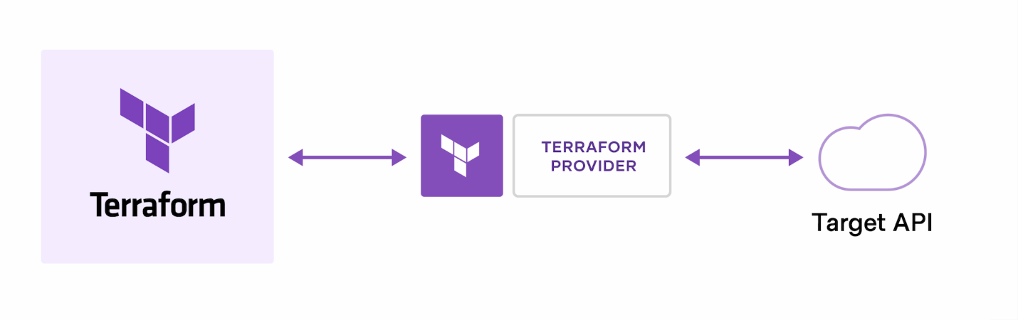
HashiCorp and the Terraform community have already written thousands of providers to manage many different types of resources and services. You can find all publicly available providers on the Terraform Registry, including Amazon Web Services (AWS), Azure, Google Cloud Platform (GCP), Kubernetes, Helm, GitHub, Splunk, DataDog, and many more.
The core Terraform workflow consists of three stages:
- Write: You define resources, which may be across multiple cloud providers and services. For example, you might create a configuration to deploy an application on virtual machines in a Virtual Private Cloud (VPC) network with security groups and a load balancer.
- Plan: Terraform creates an execution plan describing the infrastructure it will create, update, or destroy based on the existing infrastructure and your configuration.
- Apply: On approval, Terraform performs the proposed operations in the correct order, respecting any resource dependencies. For example, if you update the properties of a VPC and change the number of virtual machines in that VPC, Terraform will recreate the VPC before scaling the virtual machines.
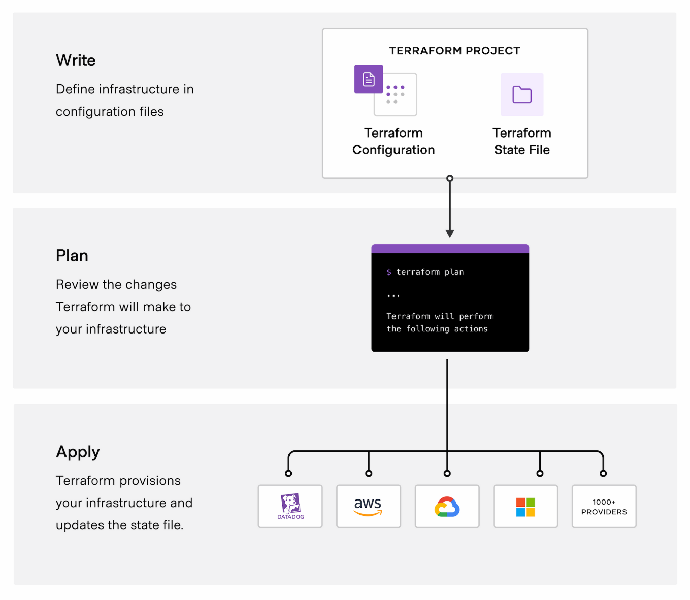
What is a Terraform State File?
The Terraform State File is a file that Terraform uses to store information about the infrastructure it manages. It records the current state of your resources so Terraform knows what already exists.
The default state file is named:
terraform.tfstate

Why is the State File Needed?
When you run Terraform commands, Terraform compares:
- Desired State → What is defined in your .tf configuration files.
- Current State → What is stored in terraform.tfstate.
By comparing these two, Terraform decides whether it needs to create, update, or delete resources.

Example
Suppose your main.tf contains:
resource "aws_instance" "web" {
ami = "ami-0abcdef1234567890"
instance_type = "t2.micro"
}
When you run:
terraform apply
Terraform:
- Creates the EC2 instance.
- Saves details about it in terraform.tfstate.
The state file stores information such as:
- Resource ID
- Instance ID
- Public IP
- Private IP
- Resource attributes

How Terraform Uses the State File
Terraform Code (.tf)
│
▼
Desired State
│
▼
terraform.tfstate
(Current State)
│
▼
Terraform compares both
│
▼
Creates / Updates / Deletes resources

Example Scenario
First Apply
terraform apply
Creates:
- EC2 Instance
State file:
EC2 Instance ID = i-0123456789abcdef0
Instance Type = t2.micro

Change the Configuration
You change:
instance_type = "t3.micro"
Run:
terraform plan
Terraform compares:
- Configuration → t3.micro
- State file → t2.micro
It detects the difference and plans to update the instance.

What Does the State File Contain?
The state file can include:
- Resource IDs
- Instance IDs
- Public and private IP addresses
- Resource attributes
- Dependency information
- Metadata about managed resources

Types of State Files
1. Local State
- Stored on your local machine.
- Default location:
terraform.tfstate
Best for:
- Learning
- Small projects

2. Remote State
- Stored in a shared backend such as an S3 bucket (often with a DynamoDB table for state locking), Terraform Cloud, or other supported backends.
- Allows teams to share the same state safely.
Best for:
- Team environments
- Production deployments

Why Is the State File Important?
- Keeps track of managed infrastructure.
- Prevents Terraform from recreating existing resources.
- Enables accurate updates and deletions.
- Stores resource dependencies.

Interview Answer
The Terraform state file (terraform.tfstate) stores the current state of the infrastructure managed by Terraform. It contains details such as resource IDs, IP addresses, and other attributes. Terraform uses this file to compare the desired state defined in the configuration with the current state of the infrastructure, allowing it to determine what resources need to be created, updated, or deleted.
Terraform primarily uses HCL (HashiCorp Configuration Language).
1. HCL (HashiCorp Configuration Language) ✅
HCL is a declarative language specifically designed for defining infrastructure.
Example:
provider "aws" {
region = "ap-south-1"
}

resource "aws_instance" "web" {
ami = "ami-0abcdef1234567890"
instance_type = "t2.micro"

tags = {
Name = "WebServer"
}
}
This tells Terraform what infrastructure you want, not how to create it.

2. JSON (Alternative Format)
Terraform configurations can also be written in JSON, although this is much less common.
Example:
{
"resource": {
"aws_instance": {
"web": {
"ami": "ami-0abcdef1234567890",
"instance_type": "t2.micro"
}
}
}
}
Most DevOps engineers prefer HCL because it is easier to read and write.

Why HCL?
- ✅ Human-readable
- ✅ Easy to learn
- ✅ Supports variables, loops, and conditions
- ✅ Designed specifically for infrastructure

HCL vs YAML
HCL | YAML
Used by Terraform | Used by Ansible
.tf files | .yml or .yaml files
Infrastructure provisioning | Configuration management and automation
Declarative | Declarative

HCL vs Python
HCL | Python
Infrastructure definition language | General-purpose programming language
Used by Terraform | Used for scripting, automation, web development, AI, etc.
Describes desired infrastructure | Contains program logic, functions, and algorithms

Interview Answer
Terraform uses HashiCorp Configuration Language (HCL) as its primary language. HCL is a declarative language used to define infrastructure resources such as EC2 instances, VPCs, subnets, and security groups. Terraform also supports JSON, but HCL is the standard and most widely used format.
how to install
wget -O - https://apt.releases.hashicorp.com/gpg | sudo gpg --dearmor -o /usr/share/keyrings/hashicorp-archive-keyring.gpg
echo "deb [arch=$(dpkg --print-architecture) signed-by=/usr/share/keyrings/hashicorp-archive-keyring.gpg] https://apt.releases.hashicorp.com $(grep -oP '(?<=UBUNTU_CODENAME=).*' /etc/os-release || lsb_release -cs) main" | sudo tee /etc/apt/sources.list.d/hashicorp.list
sudo apt update && sudo apt install terraform

